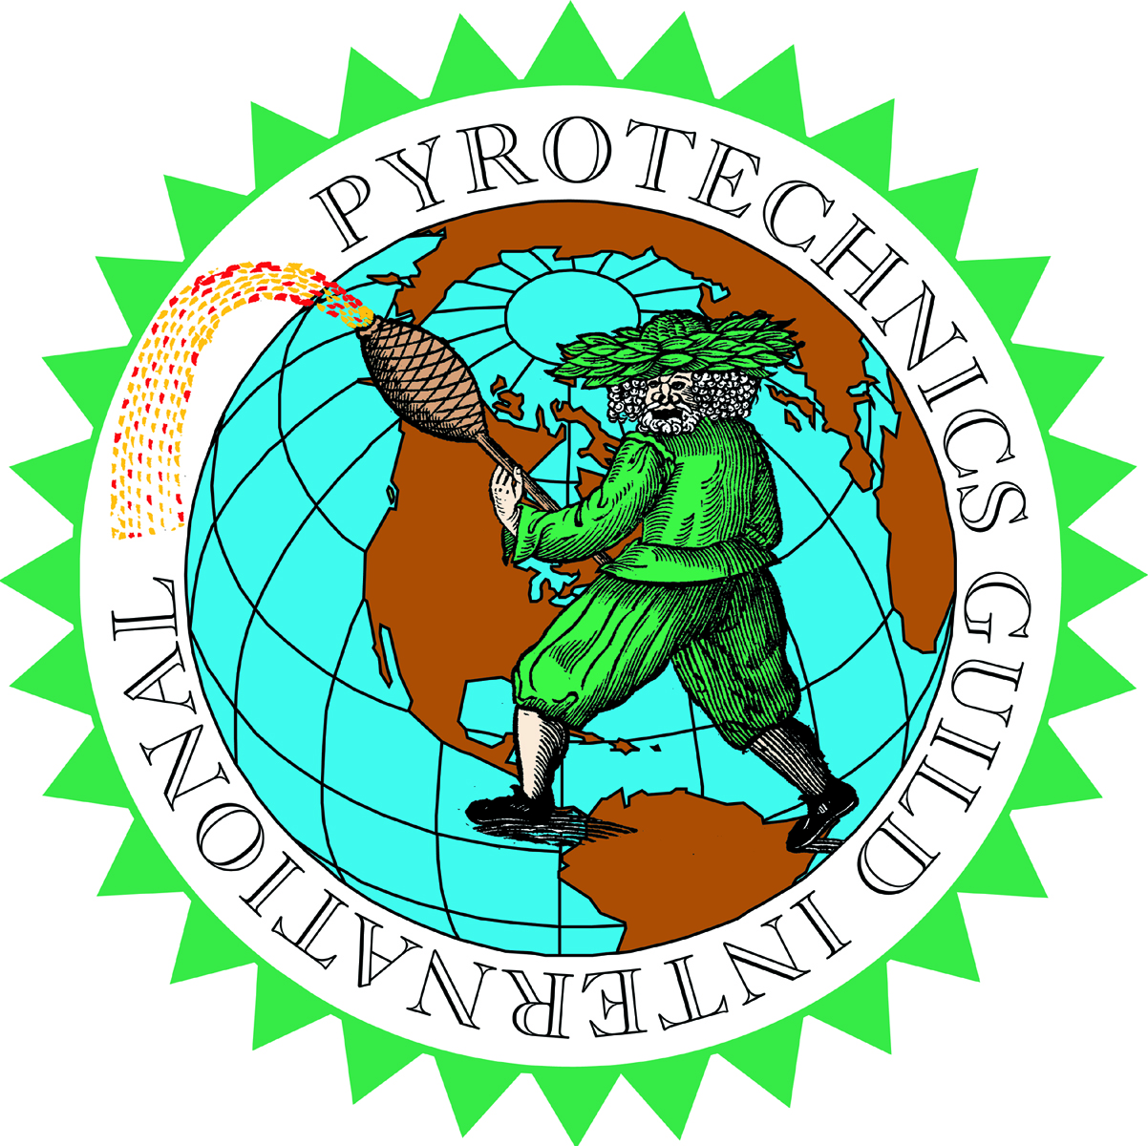

Paul E. Smith

President

www.pgi.org

www

Pyrotechnics Guild International, Inc.

2/26/2021

 Mr. Brandon Wales

Acting Director, Cybersecurity and Infrastructure Security Agency

U.S. Department of Homeland Security

245 Murray Lane

Washington, D.C. 20528

**Re: Docket No. CISA-2020-0014**

Dear Acting Director Wales:

The Pyrotechnics Guild International, Inc. respectfully submits the following comments on the above listed action.

The PGI is grateful for this opportunity to submit our comments on this action. The PGI has had representatives participate in your chemical security summit sessions and has had them give input on our concerns. We continue to strongly support the following statement excerpted from FR Vol 86, No. 3 page 496.  “Agencies have long been charged to “avoid regulations that are inconsistent, incompatible, or duplicative with [their] other regulations or those of other Federal agencies.”  Duplication within regulations costs our industry financially and occasionally leads to conflicts between regulations required by different agencies.

The ATF and DOT already provide regulations on the storage, transportation and use of these materials and the CFATS effort duplicates other regulatory Government agencies. This causes an unnecessary burden on the industry for those entities already constrained by the respective ATF and DOT regulations.

The PGI does support the removal of the 49 chemicals from Appendix A.  This does, in our opinion, help remove some of the unnecessary burden on our industry.

The ATF already does unannounced inspections which require taking time away from that day's

production duties.  Adding yet another inspection, of the same materials, and adding duplicative documentation increases time spent on the same or very similar regulatory focus.

Also quoted from FR Vol 86, No 3 page 497 “Commenters also generally have suggested that ATF’s regulations governing commerce in explosives located at 27 CFR Part 555 are sufficient and that the security obligations imposed by the CFATS under 6 CFR part 27 are unnecessary.”  The PGI agrees with these commenters and encourages that your actions be made in accordance with them.

Respectfully submitted by:

Paul E. Smith, on behalf of our organization



Paul E. Smith

President

Pyrotechnics Guild International